SHORT-TERM CLINICAL RESULTS
OF DOUBLE-BUNDLE
ANTERIOR CRUCIATE LIGAMENT
RECONSTRUCTION

Tran Dang Khoa M.D.*,
Luong Trung Hieu M.D.**,
Lam Quoc Thanh M.D., Truong Viet Thong M.D.*, et al.
* Lower Limb department, HTO., Ho Chi Minh City
** Hospital of 30/4, Ho Chi Minh City
ABSTRACT
Purpose: to evaluate the short-term clinical results of a double-bundle (DB) anterior cruciate ligament (ACL) reconstruction using an autologous Hamstring tendon.
Methods: seventy-four male patients who underwent primary double-bundle ACL reconstruction using anteromedial (AM) drilling approach from April to October 2015 at Hospital of 30/4 and Hospital for Trauma and Orthopedics. The following evaluation methods were used: clinical examination, Lysholm score and Tegner score.
Results: sixty-four patients who were followed up for a minimum of 6 months were evaluated. The Lysholm score were significantly better – from 84 points, the Lachman and pivot-shift test results were negative during up to 12 month follow-up. There were no severe complications.
Conclusions: DB ACL reconstruction using the anatomic drilling through anteromedial portal showed superior results regarding anterior and rotational stability during up to 12 month follow-up.
FULL TEXT
In ACL reconstruction, biomechanical studies have shown that DB reconstruction is better than single-bundle (SB) reconstruction regarding rotational stability¹⁻³. Furthermore, a recent meta-analysis of randomized controlled clinical trials comparing SB versus DB reconstruction⁴⁻²⁰ showed that DB reconstruction yields some superior results in objective measurements of knee stability and protection against repeat ACL rupture or a new meniscal injury after short-term follow-up²¹.
The objective of this study was to evaluate the short-term clinical results of a DB ACL reconstruction using an autologous Hamstring tendon in Vietnamese patients.
METHODS
Patients:
Seventy-four male patients came to the Lower Limp Department – Hospital for Trauma and Orthopeadics and the Orthopeadic Department – Hospital of 30/4 from April to October, 2015 for the complains of knee un-stabilities: giving way, cannot run, Lachman test (+), pivot-shift test (+)… and were diagnosed isolated ACL rupture with ACL footprint was over 12mm in length.
All the patients had medical insurance.
Sixty-four patients were periodic followed up from 6 to 12 months.
Surgical Technique:
A standard arthroscopic examination was performed through the AM and anterolateral (AL) portals. A ruptured ACL was confirmed arthroscopically. The remnant tissue of the ruptured ACL was peeled from the lateral wall of the intercondylar notch using a monopolar radiofrequency probe.
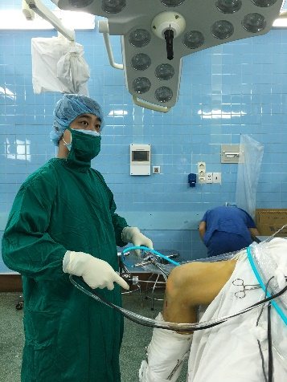

Arthroscopic knee examination

A longitudinal 3cm incision was made on the anteromedial tibial surface at the level of the pes anserinus. The Hamstring tendon was harvested, with a tendon stripper. The double-strand gracilis tendon was used for posterolateral bundle (PLB) and the double-strand semitendinosus tendon was used for anteromedial bundle (AMB). The mean diameter of the AMB graft was 5mm, and the mean diameter of the PLB graft was 6mm.
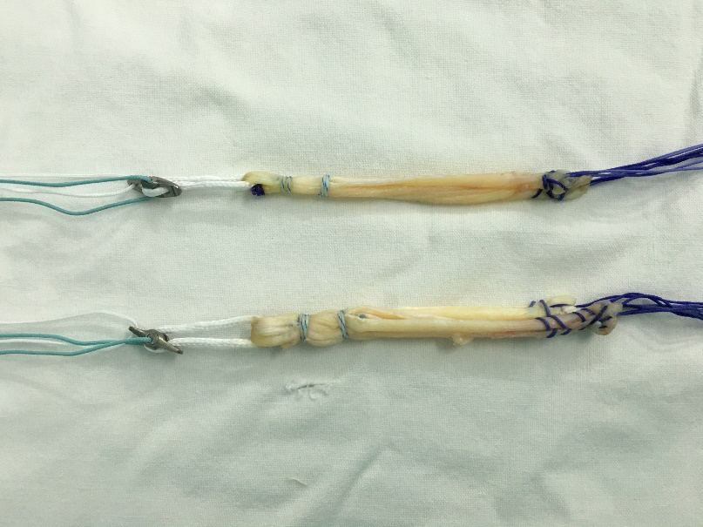
Hamstring graft preparation

Two tibial guidewires were inserted from the anteromedial surface of the tibia at the tibial tubercle level. The guidewire for the AMB was aimed at the center of the original AMB insertion with an angle of 65⁰ from the joint line on the anteroposterior radiographic view. The guidewire for the PLB was aimed at the center of the original PLB insertion with an angle of 45⁰ from the joint line on the anteroposterior radiographic view, so that the apertures of the 2 tibial tunnels could be independent.
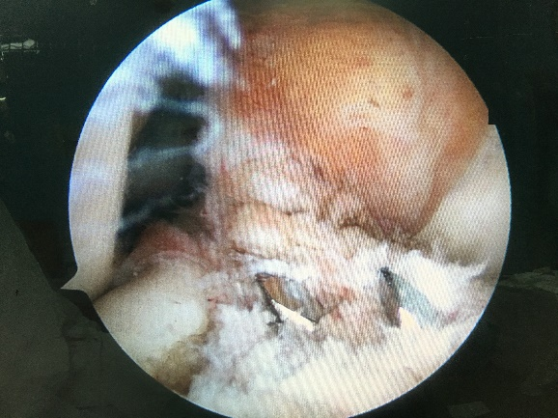
2 tibial tunnel preparation

Guidewires for the femoral drill holes were inserted by the additional AM portal (more dital and medial compares to AM portal) at full knee flexion. The center of the femoral drill hole for the AMB was aimed at the 1:30 clock-face position of the intercondylar clock in the left knee, 6mm anterior (measured by a graduated probe) to the posterior bony edge of the lateral wall. The center of the femoral drill hole for the PLB was aimed at the 3:30 clock-face position of the intercondylar clock in the left knee, 6mm anterior to the posterior bony edge of the lateral wall, with arthroscopic observation from the AL or AM portal.
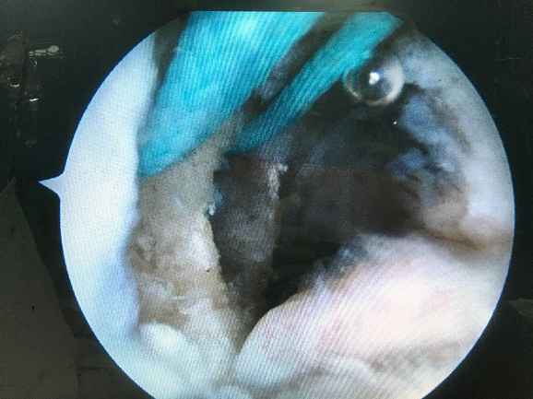
2 femoral tunnel preparation

The femoral side of the grafts were fixed with the cortical suspension devices. The AMB graft was first fixed with an interference screw at the tibial site. An initial force of 40 N was applied to the graft at 45 to 60⁰ of flexion. Then, the PLB graft was fixed at 0 to 15⁰ of flexion with the same manner.

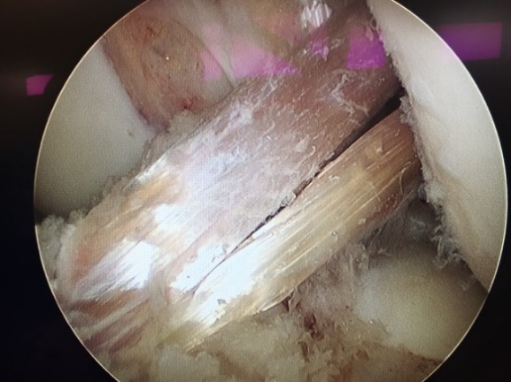
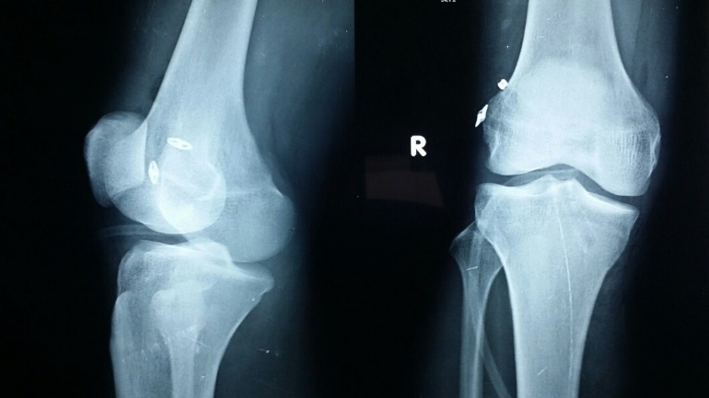
Final arthroscopic examination
Post-operative x-ray

Postoperative Management:
The postoperative rehabilitation protocol was the same for all patients. Range-of-motion exercise from full extension to 120⁰ of flexion was started at 3 days after surgery. Partial weight bearing was allowed at 3 days, and this was gradually increased. Use of crutches was discontinued at 4 weeks. Knee muscle exercise was encouraged starting 6 weeks after surgery in the closed kinetic fashion. Running exercise was started at 3 months, first as jogging; the running speed was then gradually increased. Once 80% of full-speed running was achieved, athletic exercises related to the previous sports or desired sporting activities were initiated with detailed instructions. Athletic exercises were specific to each patient, depending on the kinds of sports previously engaged in, as well as the patient’s athletic level. Full athletic activities were allowed 6 months after surgery as long as the patient did not show any problematic symptoms in the joint, with sufficient muscle recovery (>80% of extension and flexion strength compared with the uninjured knee).
Clinical Evaluations:
The knee joint condition in the pre-operative period and at the final follow-up was evaluated based on side- to-side differences between the injured leg and uninjured leg.
The Lachman test were graded as negative, 1p, 2p, or 3p according to the International Knee Documentation Committee (IKDC) form²². The patient lying supine on a bed, the examined extremity is lifted from the bed, and the leg is extended from a position of 90⁰ of flexion to full extension while a valgus and internal rotation moment is applied to the leg. The pivot-shift test was graded according to IKDC criteria²² (negative; 1p, glide; 2p, clunk; or 3p, gross).

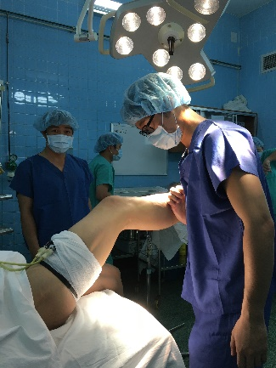
Pivot-shift test

The Lysholm knee scale was used as a general knee evaluation method.
Preoperative and postoperative Tegner scores at final follow-up were recorded to assess the sports activity level²³.
Peri- and postoperative complications were recorded.
Statistical Analysis:
Statistical analysis was performed with the SPSS software package.
RESULTS
10 patients were lost to follow-up after 1 year.
Mean time of follow-up was 8.6 months.
Right/Left side = 1/1.
Accident causes: sport (60%), motorcycle (24%), others (16%).
Mean operative duration: 45 minutes.
Hospital stay: 2 days.
Lysholm score:
44 patients (69%) reached excellent score and the rest (31%) did good one postoperatively.
Tegner score:
52 patients (81%) returned to sports activity (level 5) at 6 month follow-up.
Range of Motion:
There was no patient with a greater than 5⁰ extension or flexion deficit at final follow-up and no patient who required additional surgery because of loss of range of motion or prolonged inflammation.
Manual Knee Laxity Test:
The Lachman test and pivot-shift test were negative all time of follow-up.

Complications:
No severe complication was noted in peri- and post-operation: PCL or notch impingement, deep infection of the knee, broken tunnels, failure to fix the grafts in both sides,…
Only 5 cases of post-operative knee effusion but they were solved with few needle aspirations.
DISCUSSION
The most important finding of this study was that DB ACL reconstruction was excellent regarding anterior and rotational stability during the 6 to 12 month follow-up. In this study, negative Lachman and pivot-shift test results were found all the time of follow-up. The Lyshohm score was significant better in all followed-up patients post-operatively, from 84 points (excellence and good). We were also not able to detect any severe complications peri- and post-operatively.
Actually, most of the patients came to us for the first examination without supporter at the time of 2 weeks post-operatively. This suggested that DB ACL reconstruction controlled knee rotational stability better.
The Tegner score indicated that sports activity was maintained at 6 months.
Limitations:
There were some limitations in this study. First, the follow-up time was short; only 6 to 12 months. Second, we evaluated rotational stability only by the subjective pivot-shift test. Finally, this study did not implement an arthroscopic second look for evaluation of the grafts.
CONCLUSION
DB ACL reconstruction using the AM drilling approach with autologous Hamstring showed excellent result regarding anterior and rotational stability during the 6 to 12 month follow-up. Knee function recovery was almost full at 6 months without severe complications.
REFERENCES
- Koga H, Muneta T, Yagishita K, Ju YJ, Sekiya I. The effect of graft fixation angles on anteroposterior and rotational knee laxity in double-bundle anterior cruciate ligament reconstruction: Evaluation using computerized navigation. Am J Sports Med 2012;40:615-623.
- Yagi M, Wong EK, Kanamori A, Debski RE, Fu FH, Woo SL. Biomechanical analysis of an anatomic anterior cruciate ligament reconstruction. Am J Sports Med 2002;30:660-666.
- Woo SL, Kanamori A, Zeminski J, Yagi M, Papageorgiou C, Fu FH. The effectiveness of reconstruction of the anterior cruciate ligament with hamstrings and patellar tendon. A cadaveric study comparing anterior tibial and rotational loads. J Bone Joint Surg Am 2002;84:907-914.
- Adachi N, Ochi M, Uchio Y, Iwasa J, Kuriwaka M, Ito Y. Reconstruction of the anterior cruciate ligament. Single- versus double-bundle multistranded hamstring tendons. J Bone Joint Surg Br 2004;86:515-520.
- Aglietti P, Giron F, Losco M, Cuomo P, Ciardullo A, Mondanelli N. Comparison between single-and double- bundle anterior cruciate ligament reconstruction: A pro- spective, randomized, single-blinded clinical trial. Am J Sports Med 2010;38:25-34.
- Araki D, Kuroda R, Kubo S, et al. A prospective rando- mised study of anatomical single-bundle versus double- bundle anterior cruciate ligament reconstruction: Quantitative evaluation using an electromagnetic mea- surement system. Int Orthop 2011;35:439-446.
- Ibrahim SA, Hamido F, Al Misfer AK, Mahgoob A, Ghafar SA, Alhran H. Anterior cruciate ligament recon- struction using autologous hamstring double bundle graft compared with single bundle procedures. J Bone Joint Surg Br 2009;91:1310-1315.
- Misonoo G, Kanamori A, Ida H, Miyakawa S, Ochiai N. Evaluation of tibial rotational stability of single-bundle vs. anatomical double-bundle anterior cruciate ligament reconstruction during a high-demand activitydA quasi- randomized trial. Knee 2012;19:87-93.
- Muneta T, Koga H, Mochizuki T, et al. A prospective randomized study of 4-strand semitendinosus tendon anterior cruciate ligament reconstruction comparing single-bundle and double-bundle techniques. Arthroscopy 2007;23:618-628.
- Park SJ, Jung YB, Jung HJ, et al. Outcome of arthroscopic single-bundle versus double-bundle reconstruction of the anterior cruciate ligament: A preliminary 2-year pro- spective study. Arthroscopy 2010;26:630-636.
- Sastre S, Popescu D, Nunez M, Pomes J, Tomas X, Peidro L. Double-bundle versus single-bundle ACL reconstruction using the horizontal femoral position: A prospective, randomized study. Knee Surg Sports Traumatol Arthrosc 2010;18:32-36.
- Siebold R, Dehler C, Ellert T. Prospective randomized comparison of double-bundle versus single-bundle ante- rior cruciate ligament reconstruction. Arthroscopy 2008;24: 137-145.
- Song EK, Oh LS, Gill TJ, Li G, Gadikota HR, Seon JK. Prospective comparative study of anterior cruciate liga- ment reconstruction using the double-bundle and single- bundle techniques. Am J Sports Med 2009;37:1705-1711.
- Streich NA, Friedrich K, Gotterbarm T, Schmitt H. Reconstruction of the ACL with a semitendinosus tendon graft: A prospective randomized single blinded compari- son of double-bundle versus single-bundle technique in male athletes. Knee Surg Sports Traumatol Arthrosc 2008;16: 232-238.
- Suomalainen P, Moisala AS, Paakkala A, Kannus P, Jarvela T. Double-bundle versus single-bundle anterior cruciate ligament reconstruction: Randomized clinical and magnetic resonance imaging study with 2-year follow-up. Am J Sports Med 2011;39:1615-1622.
- Volpi P, Cervellin M, Denti M, et al. ACL reconstruction in sports active people: Transtibial DB technique with ST/G vs. transtibial SB technique with BPTB: Preliminary re- sults. Injury 2010;41:1168-1171.
- Wang JQ, Ao YF, Yu CL, Liu P, Xu Y, Chen LX. Clinical evaluation of double-bundle anterior cruciate ligament reconstruction procedure using hamstring tendon grafts: A prospective, randomized and controlled study. Chin Med J (engl) 2009;122:706-711.
- Yagi M, Kuroda R, Nagamune K, Yoshiya S, Kurosaka M. Double-bundle ACL reconstruction can improve rota- tional stability. Clin Orthop Relat Res 2007;454:100-107.
- Zaffagnini S, Bruni D, Russo A, et al. ST/G ACL recon- struction: Double strand plus extra-articular sling vs double bundle, randomized study at 3-year follow-up. Scand J Med Sci Sports 2008;18:573-581.
- Zaffagnini S, Bruni D, Marcheggiani Muccioli GM, et al. Single-bundle patellar tendon versus non-anatomical double-bundle hamstrings ACL reconstruction: A pro- spective randomized study at 8-year minimum follow-up. Knee Surg Sports Traumatol Arthrosc 2011;19:390-397.
- Tiamklang T, Sumanont S, Foocharoen T, Laopaiboon M. Double-bundle versus single-bundle reconstruction for anterior cruciate ligament rupture in adults. Cochrane Database Syst Rev 2012;11:CD008413.
- Hefti F, Muller W, Jakob RP, Staubli HU. Evaluation of knee ligament injuries with the IKDC form. Knee Surg Sports Traumatol Arthrosc 1993;1:226-234.
- Tegner Y, Lysholm J. Rating systems in the evaluation of knee ligament injuries. Clin Orthop Relat Res 1985;(198): 43-49.

